***Web Crawler***

***In***

***Search Engine Optimization (SEO)***

**MINI PROJECT -I**

Submitted in partial fulfillment of the requirements

For the award of the degree of

Bachelor of Technology

(Computer Science and Engineering)

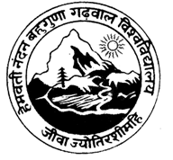

Guide: Submitted by:

Mr. AMIT PANWAR Himanshu Beniwal

(2015-2019)

Department of Computer Science and Engineering

Hemwati Nandan Bahuguna, Garhwal University

Srinagar Garhwal

(A Central University)